Manuscript Preparation for ACE2014, 11th International Congress on Advances in Civil Engineering

A. B. Surname¹, C. D. Surname²

¹Department of Civil Engineering, ITU, Istanbul, Turkey, e-mail
²Department of Civil Engineering, ITU, Istanbul, Turkey, e-mail

Abstract

This document template is designed to guide authors in writing their papers by direct editing. Alternatively, authors can use this manuscript and follow the guidelines to adjust format of their paper to the required form. This “abstract” section is limited to a maximum of 250 words. The authors are required to present a short summary of their study including their findings, conclusions and outcomes.

Keywords: this section should be written in italic and include a maximum of 5 keywords related with the study.

1 Introduction

Submission of full papers will be due to April 15, 2014. Paper submissions must be in electronic copy, in Microsoft Word and PDF Document.

2 Guidelines

Authors should consider the following guidelines in writing their papers. The paper size must be customized to A4 size paper. The page setup must be adjusted such that all margins are 2.5 cm. The body text should be aligned to “justified” style and line spacing must be single.

Font type Times New Roman, size 10 pts should be used throughout the whole text (also for the line spaces). There should not be any underlined words. Spacing in the first page must be adjusted as follows: starting from the first line, enter 5 spaces and write the title of the paper (16 pts, Bold), enter 3 spaces and write name and surname of the authors as shown above (12 pts, Bold), enter 1 space and write the affiliation of each author to a separate line (10 pts), enter 3 spaces and write the title “abstract” (12 pts, Bold). Enter 1 space after the title. At the end of the abstract, enter 1 space and write the title “keywords” (10 pts, Bold, Italic, include maximum 5 keywords), enter 2 spaces and write the first section heading “introduction”. The maximum length of manuscript is 6 pages including figures and tables. Information on numbering and format for headings are given in the next section.

SI (international system) units must be used throughout the whole text.

3 Section Headings

Type each section heading in 12 pts, and number sequentially except for the References section. Enter 1 line space after section titles. Enter 2 line spaces between section titles and each paragraph within the body text.

3.1 Format for Subsection Headings

First subsection heading should be formatted with 12 pts font size and bold style. Enter 1 line space after these headings and 2 lines between subsection heading and each paragraph within the body text.

3.1.1 Format for Subsection Headings

Other subsection headings should be formatted with 11 pts font size and italic style. Enter 1 line space after these headings and 2 lines between subsection heading and each paragraph within the body text.

4 Tables and Figures

Use the same format for plain text in table and figure captions. The labeling and numbering must be written in bold characters. Table and figure captions must be centered and separated from the plain text with 1 line space. Tables and figures must also be separated by 1 line space from both the plain text and their captions. Both tables and figures should be adjusted to “in-line text” format and must be formatted to sit horizontally centered (please see Table 1 and Figure 1).

Table 1. Undisturbed sample properties.

Sample ID | Depth  (m) | Bulk density,ρ_{b} (g/cm³)
S2-1 | 6.00-6.30 | 1.80
S2-2 | 6.00-6.30 | 1.85
S2-3 | 9.40-9.70 | 1.93
S2-4 | 9.40-9.70 | 1.90

Figure 1. SPT blow counts for the profile investigated.

Adjust pictures, if any, to be in 300 dpi resolution (at most) and 150 dpi (at least) with color quality as shown in Figure 2.

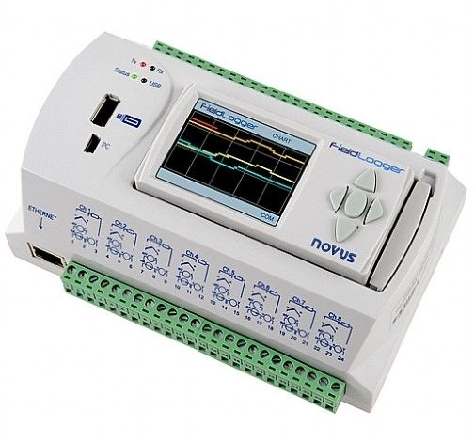

Figure 2. Data acquisition unit.

4 Equations

Equations should be written by using “Microsoft Word Equation Editor”. All Greek symbols and Latin symbols in the equations must be typed with “Times New Roman” style. Do not write text in equation editor as shown in Equation 1.

$G_{i}=\left[1+\frac{{\text{ρK}}_{d}}{n}\right]λ_{i}c_{i}+\frac{{\text{ρK}}_{d}}{n}\frac{∂c_{i}}{∂t}$ (1)

Equations must be formatted to be “in-line-text” using indentation of 1cm, with the equation number aligned to the right most of the page width. As in the format of tables and figures, there should be 1 line space between equations and both underlying and overlying paragraphs. The font sizes which should be used in equation editor are shown in Figure 3.

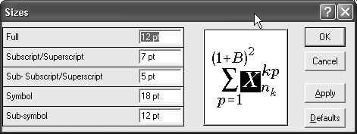

Figure 3. Format screen for equation editor.

The definition of each symbol or parameter in the equation can be given below the equation, after entering 1 line space.

5 Citations

You must document whenever you quote, paraphrase, summarize, or use any idea, fact, or figure from source material (unless the material is “common knowledge”). For your manuscript, you should use in-text parenthetical references in conjunction with an alphabetized References list using APA style. In-text citation example can be done as in this sentence (Fredlund and Rahardjo, 1993). In the case of more than two authors, et al. should be used after following the first author, e.g. (Aung et al., 1998). In technical documents by government agency or institutes, for the first citation, the agency name should be spelled out with the acronym (if it was not done before in the text), such as, (Environmental Protection Agency [EPA], 1988), while for the second citation, only the acronym should be used.

In APA style Reference list should be sorted in alphabetical order according to the surname of the first author in an ascending form. Numbering should not be used for references, and there should be no line space between subsequent references. References should be indented with 1 tab stop (use 0.5 cm for tab stop) from the left margin, except the first line of each reference (see the examples below). The references must be given in the text as the author(s) last name and the date in parentheses, such as (Fredlund and Rahardjo, 1993).

References

Adanur, S. and Dumanoglu, A.A. (2002). Stochastic dynamic analyses of suspension bridges subjected to asynchronous ground motions. Fifth International Congress on Advances in Civil Engineering, ACE2002, September 25-27, Vol. 1, pp. 597-606, Istanbul, Turkey.
Aung, K.K., Rahardjo, H., Leong, E.C. and Toll, D.G. (2001). Relationship between porosimetry measurement and soil-water characteristic curve for an unsaturated residual soil. Geotechnical and Geological Engineering. Vol. 19, pp. 401-416.
Environmental Protection Agency (1988). Report on snail darter threat (No. 5634-223). Washington, DC: U.S. Government Printing Office.
Fredlund, D.G. and Rahardjo, H. (1993). Soil Mechanics for Unsaturated Soils. John Wiley and Sons Inc. New York.
Lee, M.C. and Penzien, J. (1980). Stochastic seismic analysis of nuclear power plant structures and piping systems subjected to multiple support excitations. Report No: UCB/EERC-80/19, Earthquake Engineering Research Center, College of Engineering, University of California, Berkeley, CA.

